<https://www.guru99.com/microsoft-azure-tutorial.html>

**Azure short notes**

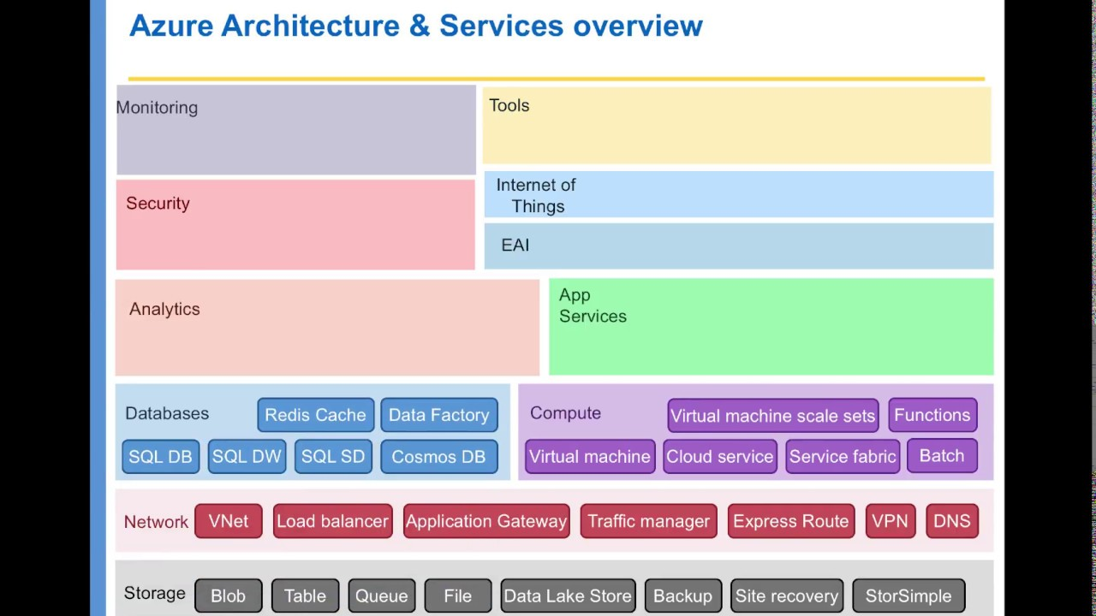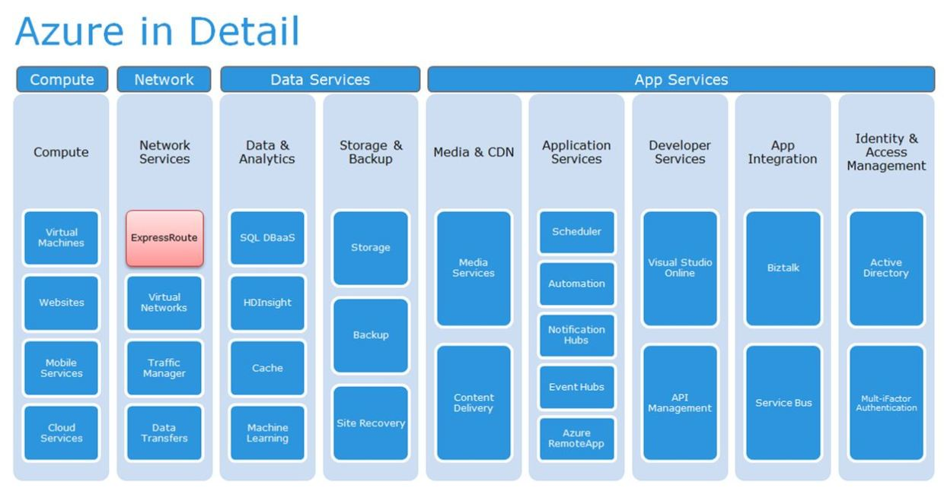

* **Computing:** The computing services are offered by Azure for managing the virtual machines, supporting remote applications, containerization and batch processing.
* **Web:** The web services offered by Azure include the one’s used for the development and deployment of web applications along with the services for search, API management, content delivery among others.
* **Storage:** Azure offers a whole range of services for scalable cloud storage for both structured and unstructured data. This support is available for big data, persistent storage and archival storage.
* **Networking:**Azure virtual network services are offered to establish dedicated connections and gateways and also for load balancing, traffic management, DNS hosting and network security.
* **Analytics:**The range of analytical services offered by Azure include big data analytics, real-time analytics, machine learning, IoT, data warehousing among others.
* **Content Delivery:** Azure offers services for globally-distributed network for content caching, on-demand streaming services, media playback, encoding and son on.
* **Identity and Access Management:** The Azure IAM services ensure authorized access to Azure network, encryption, protecting sensitive information, Azure Active Directory and so on.
* **Hybrid Integration:** Azure offers services in on-premise infrastructure connection with Azure datacenters, server backup and recovery.

**Compute**It is used to process data on the cloud by making use of powerful processors which serve multiple instances at a time.

* Virtual Machines
* VM Scale Sets
* Azure Container
* Container Registry
* Functions
* Batch
* Service Fabric
* Cloud Services

### **Azure Compute**

It gives the products that are of building level which determines the execution of an application deployed in the Azure platform. Following are the different services that Azure provides: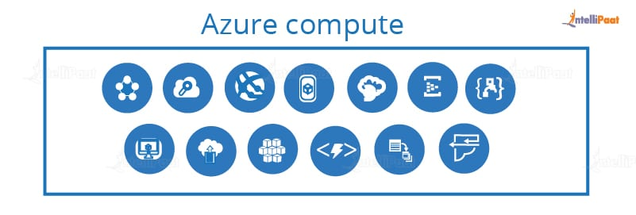

**Azure Virtual machine**: it is an environment that allows the user to have a similar experience as that of while using dedicated hardware.

**Azure Virtual machine set**: they are used to create thousands of identical virtual machines in a jiffy.

**Azure container service**: containers are packages that do not need virtual machines and instead depend on virtual isolation to run applications that have shared OS kernel. And Azure container service creates a container hosting solution.

**Azure container registry**: is used to store and manage container images

**Azure Functions**: it doesn’t have a server and lets you run code-on-demand without infrastructure.

**Azure Batch**: it is used to scale N number of virtual machines at a time.

**Azure Service fabric**: it is a distributed platform that simplifies the deployment and lifecycle management of a small service-based application.

**Azure Cloud services**: focuses on apps and support Java,Node.js, PHP, Python, .Net, and Ruby.

**Web Apps**: creates and deploys web apps at scale very quickly.

**Azure Mobile app**: building and hosting backend for any application on mobile.

**API Apps**: is used to build cloud APIs easily.

**Azure Search**: provides search-as-a-service which is fully managed.

**Notification hubs**: used to send push notifications to any platform from any backend easily.

**Azure Logic Apps**: it is a cloud service that will help you in automating workflows, business processes, etc.

**Azure Event hub**: a collection of events that can be stored.

**Storage Services**The storage as the name suggests, is used to store data in the cloud with the ability to scale as and when required. This data can be stored anywhere.

* Blob Storage
* Queue Storage
* File Storage
* Table Storage

## **Azure Storage Types**

There are four primary Azure Storage types with an additional disk storage.

* **Azure blob storage**: It is optimized to store huge unstructured data. Storage is in terms of binary large objects (BLOBs).
* **Azure table storage**: It has now become a part of Azure Cosmo DB. Azure table stores structured NoSQL data.
* **Azure file storage:**It is a fully managed file sharing service in the cloud or on-premise via the Server Message Block (SMB) protocol.
* **Azure queue storage:**It is a storage service that stores messages that can be accessed through HTTP or HTTPS from any part of the globe.
* **Disk storage:**It is a virtual hard disk (VHD) which is of two types: managed and unmanaged.

**Database**The database domain is used to provide reliable relational and non relational database instances managed by Azure.

* SQL Databases
* DocumentDB
* Redis Cache

### Azure Database

Azure Database is a relational database-as-a-service that is reliable and secure, and it gives high performance without having to worry about any infrastructure.

### Azure Database-What is Microsoft Azure-Intellipaat

**Azure SQL Database:** is a relational database hosted in Azure and built on SQL server technologies. It provides scalable, highly available and fault-tolerance database

**Azure DocumentDB**: is a NoSQL database-as-a-service whose features are a transactional process over no schema data, rich querying and query processing and transaction semantics that are similar to the relational databases.

**Azure Redis Cache**: is a data structure that implements a key-value database with optional durability.

So, those were the services of Azure but there is a lot to it. Coming back to our question, what is Microsoft Azure, let us see why companies are opting for Azure, in the next section.

**Networking**It includes services which provide a variety of networking features such as security, faster access etc.

* Virtual Network
* Load Balancer
* Application Gateway
* Azure DNS
* Content Delivery Network
* VPN Gateway
* Traffic Manager
* Express Route

### **Azure Networking**

These networks allow enterprises to safely connect to their cloud resources through Azure ExpressRoute. It is also used to manage private virtual networks and, further, create multiple virtual networks.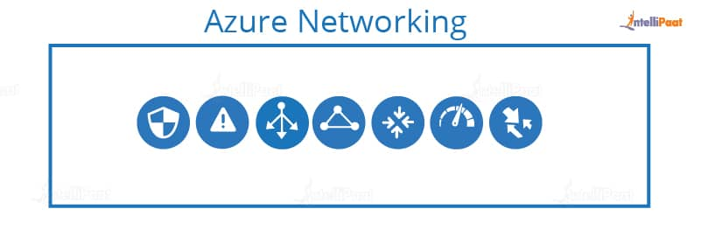 **Azure Virtual network**: it performs network isolation and segmentation with filters which routes the traffic. It comprises of Azure Connect which allows easy setup of IP-based and Azure Traffic Manager.

**Azure Load Balancer**: it balances a load of traffic going to virtual machines and isolates the external traffic to another virtual machine

**Azure Traffic Manager**: provides load balancing features.

**Azure Express Route**: it is a network that lets you extend the current network into Microsoft cloud over a private connection.

**Azure DNS**: it translates a website to IP address

**Content delivery network (CDN)**: it helps in improving delivering of content and allows the streaming of content by using the location of 24 different locations that are distributed throughout the world.

**Azure VPN gateway**: it sends encrypted traffic across a public connection

**Developer Tools**It includes services which provides services that ease the ability to code for an organization. For example: it eases the teams to share code, track work and ship software.

* Visual Studio Team Services
* Application Insights
* API Management

**Management and Monitoring Tools**It includes services which can be used to manage and monitor your Azure instances.

* Microsoft Azure Portal
* Azure Resource Manager
* Automation

### Monitoring + Management Services

These services allow easy management of Azure deployment.

* Azure Resource Manager: It makes it easy for you to manage and visualize resource in your app. You can even control who is your organization can act on the resources.
* Automation: Microsoft Azure Automation is a way to automate the manual, long-running, error-free, and constantly repeated tasks. These tasks are commonly performed in a cloud and enterprise environment.

**Enterprise Integration**Services that bring functionalities like seamlessly integrating the enterprise and the cloud.

* Service Bus
* SQL Server Stretch Database

**Security and Identity**It includes services for user authentication or limiting access to a certain set of audience on your Azure resources.

* Key Vault
* Azure Active Directory
* Azure AD B2C
* Azure AD Domain Services
* Multi Factor Authentication

**Security + Identify sevices**

It provides capabilities to identify and respond to cloud security threats. It also helps you to manage encryption keys and other sensitive assets. It has the following components:

* Key Vault: Azure Key Vault allows you to safeguard cryptographic keys and helps you to create secrets used by cloud applications and services.
* Azure Active Directory: Azure Active Directory and identity management service. This includes multi-factor authentication, device registration, etc.
* Azure AD B2C: Azure AD B2C is a cloud identity management solution for your consumer-facing web and mobile applications. It allows you to scales hundreds of millions of consumer identities.

**Web and Mobile Apps**These are mainly used to create web apps or mobile apps for any platform and any device.

* Web Apps
* Mobile Apps
* API Apps
* Logic Apps
* Notification Hubs
* Event Hubs
* Azure Search

### Web and Mobile Services:

* Web Apps: Web Apps allows you to build and host websites in the programming language of your choice without the need to manage its infrastructure.
* Mobile Apps: Mobile Apps Service offers a highly scalable, globally available mobile app development platform for users.
* API Apps: API apps make it easier to develop, host and consume APIs in the cloud and on-premises.
* Logic Apps: Logic Apps helps you to simplify and implement scalable integrations

### Enterprise Integration Services:

* Service Bus: Service Bus is an information delivery service which works on the third-party communication system.
* SQL Server Stretch Database: This service helps you migrates any cold data securely and transparently to the Microsoft Azure cloud
* Azure AD Domain Services: It offers managed domain services like domain join, group policy, LDAP, etc. This authentication which is compatible with Windows Server Active Directory.
* Multi-Factor Authentication: Azure Multi-Factor Authentication (MFA) is two-step verification. It helps you to access data and applications to offers a simple sign-in process.